1. Install Python.
2. Install xampp
3. Start mysql server after running xampp.
4. Create database and table.
5. Install pip library for python by running the bellow commend.
   1. python get-pip.py (if it is not installed)
   2. check pip status by running the command pip –v

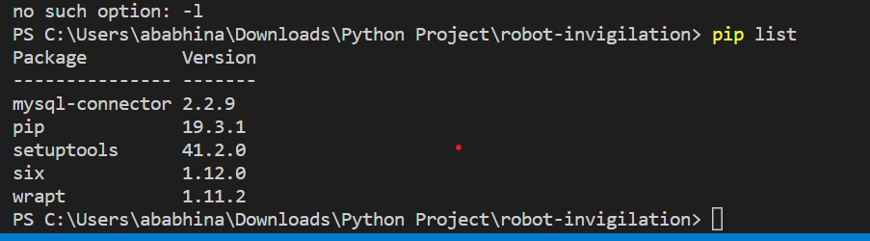

1. run pip list to know the list of library’s installed. If any one is missing install them by running the command: python -m pip install --mysql-connector—(name of the package).